**Banking system globalization in the US banking system**

The globalization of the US banking system has undergone significant changes over the years.

**1962-1981: The Era of Rapid Expansion**

**Number of Foreign Branches:** The number of foreign branches of US commercial banks increased from a handful in 1960 to nearly 1,000 by 1980.

**Percentage of Total Assets:** Foreign assets of US banks grew from 3.5% of total assets in 1960 to 12.5% by 1980.

**1980s-2000s: Decline and Rebound**

**Number of Foreign Branches:** The number of foreign branches of US commercial banks declined from 1,000 in 1980 to around 200 in 2000, but then rebounded to around 500 by 2010.

**Percentage of Total Assets:** Foreign assets of US banks declined from 12.5% of total assets in 1980 to around 5% by 2000, but then increased to around 10% by 2010.

**2008 Financial Crisis**

**Federal Reserve Intervention:** The US Federal Reserve Bank played a crucial role in stabilizing the global banking system by lending over $1 trillion to other central banks during the 2008 financial crisis.

**Current Trends**

**Global Banking Presence:** The top five US banks with the greatest international business in 1960 (Citibank, Chase Manhattan, Bank of America, Bank of Boston, and JP Morgan) still dominate foreign corporate lending in 1999.

**Banking Sector Globalization:** The banking sector in the US has become more globalized, with foreign banks operating in the country and US banks operating abroad.

**Decline in the Number of Banks**

* The number of banks in the U.S. has declined from around 15,000 in 1985 to 4,500 today.
* The Office of the Comptroller of the Currency (OCC) supervised nearly 6,500 institutions with $2 trillion in assets in 1984, compared to 1,000 institutions with over $15 trillion in assets today.

**Concentration in Large Banks**

* The U.S. banking system is highly concentrated, with the eight global systemically important banks (G-SIBs) dwarfing the next largest banks.
* The assets of the G-SIBs rival the aggregate assets of the 4,000-plus banks smaller than $100 billion.

**Globalization Trends**

* After decades in decline, international banking again started increasing in importance with the Second Age of Globalization starting in the late 20th century.
* The proportion of domestic bank claims to total bank claims has fallen from around 78% in 1992-1995 to 70% in 2002, indicating banks have increased their foreign claims faster than domestic claims.

**Impact on Efficiency**

* Analyzing 126 countries from 1995-2013, a study found that bank globalization has a positive impact on bank efficiency, with heterogeneous effects depending on host and home country characteristics.
* The study found that a 1% increase in the ratio of foreign bank assets to total bank assets is associated with a 0.0793% increase in cost efficiency.

**The impact of banking globalization on the stability of the US financial system**

**Increased Interconnectedness**

**Increased Cross-Border Flows:** Financial globalization has led to a significant increase in cross-border financial flows, which has increased the interconnectedness of the global financial system.

**Risks and Vulnerabilities**

**Financial Instability:** Financial globalization can lead to financial instability and crises, particularly in emerging market economies where financial systems are less developed.

**Risk Management:** The entry of foreign banks can lead to improved risk management techniques, but it also increases the risk of financial instability if these banks are not adequately regulated.

**Impact on the US Financial System**

**Federal Reserve Intervention:** The US Federal Reserve played a crucial role in stabilizing the global banking system during the 2008 financial crisis by lending over $1 trillion to other central banks.

**Regulatory Challenges:** The international regulatory system created in 2008 has been either ineffective or weakened due to political pressures and geopolitical tensions, which has raised concerns about the stability of the US financial system.

**Future Outlook**

**Reduced US Global Economic Influence:** The US role in the global financial system is changing, and there are doubts about whether the Fed would be willing or able to lead another large-scale bank rescue like in 2008.

**Benefits of US banks having a global presence**

**Increased Trade and Economic Growth**

Foreign banks can facilitate trade by providing financing to exporters and importers, which can lead to increased economic growth and development.

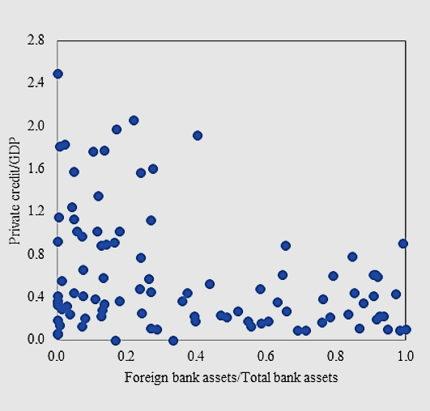

**Improved Risk Management**

Global banks can better manage risks by diversifying their assets and liabilities across different countries and markets, reducing their exposure to any one particular market or currency.

**Enhanced Customer Services**

Global banks can offer a wider range of financial services and products to their customers, including international trade finance, treasury services, and investment banking[4].

**Increased Efficiency and Cost Savings**

Global banks can leverage their international presence to reduce costs and increase efficiency by consolidating operations, sharing resources, and taking advantage of economies of scale.

**Access to New Markets and Clients**

Global banks can expand their customer base by entering new markets and serving clients globally, which can lead to increased revenue and profitability.

**Improved Reputation and Credibility**

Global banks can enhance their reputation and credibility by demonstrating their ability to operate successfully in multiple markets and jurisdictions.

**Increased Financial Stability**

Global banks can contribute to financial stability by providing liquidity and stability to the global financial system, particularly during times of crisis.

